Hotmaps - Open source platform and open data set on heating and cooling in EU28
Michael Hartner⁽¹⁾, Mostafa FALLAHNEJAD⁽¹⁾
Marcus HUMMEL ⁽²⁾, Andreas MÜLLER ⁽²⁾, Sara Fritz⁽³⁾, Lukas KRANZL ⁽¹⁾
⁽¹⁾TU Wien, Energy Economics Group, ⁽²⁾e-think, ⁽³⁾IFEU

Introduction
Within this conference contribution a web-based tool for heating and cooling mapping and planning is presented. The tool for which a beta version will be published in March 2019 allows to:
- map heat demand on different geographical levels across EU28 member states as well as Switzerland and Norway (from country level down to individually selected areas on municipality or district level)
- map climate conditions relevant for heating and cooling planning
- map renewable resources on different geographical levels
- retrieve basic indicators on all datasets that are included in the toolbox
- identify areas that can be suitable for district heat and cooling
- perform customized online calculations based on the datasets in the toolbox
- export the each dataset as whole or for selected regions
The tool is developed within the H2020 project Hotmaps [1]. Within the conference the main functionalities of the tool will be presented live.
Methodology
The tool as well as the data behind the tool are open source. The code is hosted on GitHub while the datasets can already be downloaded from GitLab [2]. All tool functionalities can be used through standard browsers.

The backbone of the tool is an EU28 default dataset [3] which consists of several spatially highly disaggregated raster layers and additional datasets on NUTS 3 to NUTS 0 level. The idea of the tool is to combine these datasets on different geographical levels and provide relevant information for heating and cooling planning.

Being aware that the default datasets can deviate significantly from the actual figures in particular on local level and that some local authorities already have better and more detailed datasets available the toolbox will also allow for uploads of datasets by individual users. Furthermore other researchers are invited to add new default datasets to the toolbox which can be integrated through adding a GitLab [2] repository including information on the meta-data. (Please see [4] as an example for correct meta data description to include a raster file into the Hotmaps toolbox). The datasets published on GitLab are then processed and integrated into a Geoserver and Geographic information system database automatically. The database includes the original raster files as well as tables with pre-calculated statistics on the datasets to facilitate the calculation of indicators. Indicators for larger areas are retrieved from those pre-calculated tables, while indicators for smaller user-defined area selections are calculated on the fly by the toolbox.

In addition to visualizations and basic indicators the toolbox also provides the possibility to integrate more complex calculation modules. Those calculation models can communicate with the database to retrieve inputs for the modules and with the front end through defined interfaces. The calculation modules can pass on their results in the form of graphs, indicators and layers which are then provides for the user on the front end. Within the project several calculations modules on district heating potentials and costs, decentral heating costs, excess heat potentials, renewable potentials, etc. are developed. However, being designed as an open source project the intention is to open the toolbox to interested researchers and developers to add additional calculation modules to the toolbox in the future.
Figure 1 provides an overview of the content structure of the toolbox and its components.
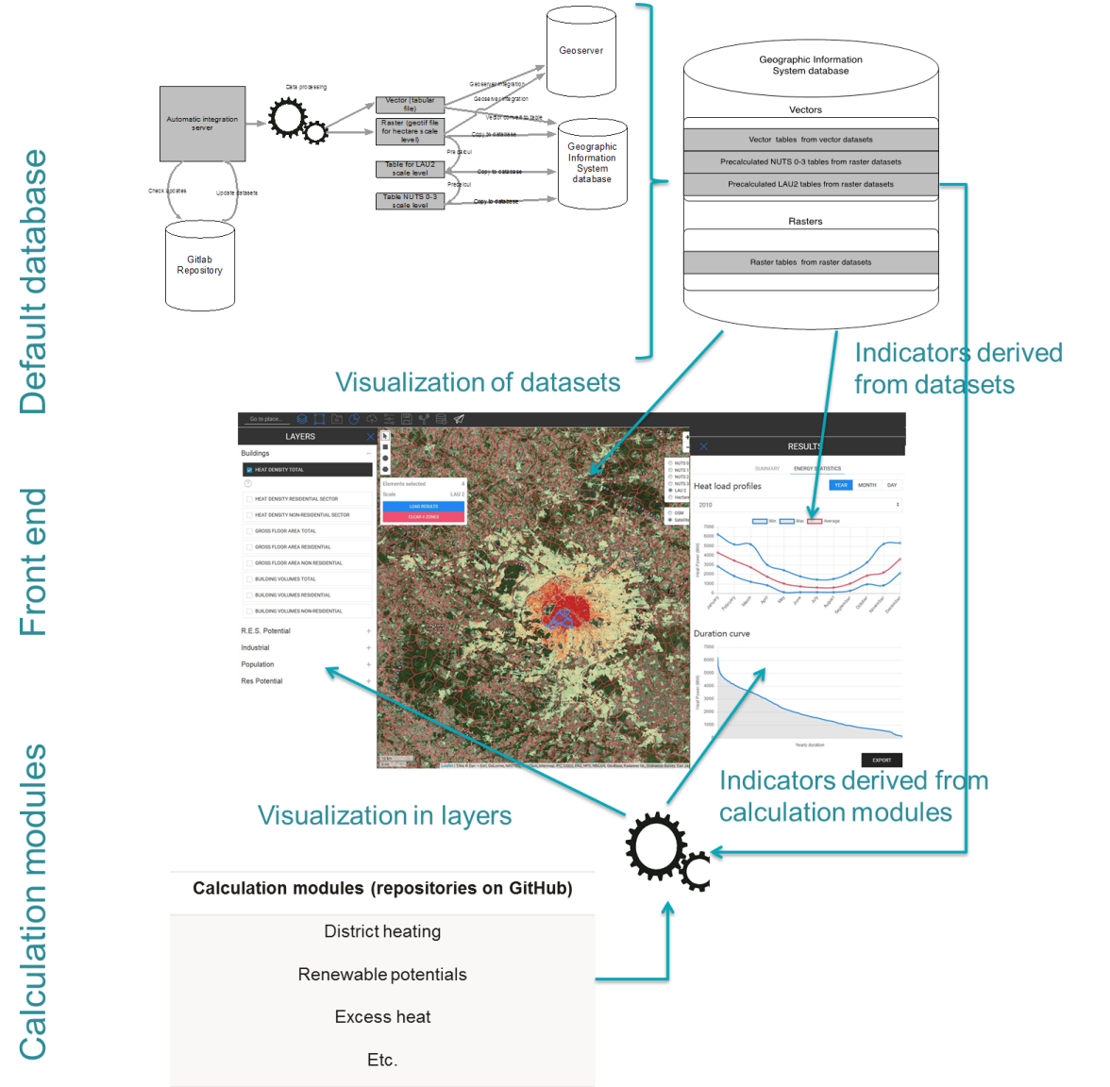
Figure 1: Structure and components of the Hotmaps toolbox
Results
So far a version of the toolbox was developed that includes the main mapping functionalities based on a selection of datasets from GitLab repositories. Both the visualization of layers as well as the calculation of indicators are developed. The calculation of indicators for individually selected areas seems to be a novelty for GIS-based online tools (to the knowledge of the authors) and is considered to be very valuable for energy planners in the future.
The tool is considered to be rather easy to use compared to other GIS based desktop tools (e.g. QGIS, ArcGIS), which of course provide much more functionalities than the tailor made Hotmaps toolbox. Furthermore the availability of default data allows users to perform analysis and get first insights on their regions without the need for time consuming data collection. Furthermore the analysis of GIS based data typically also involves the knowledge of GIS-software (e.g. QGIS). The Hotmaps toolbox however is designed to be used by anyone including energy planners or authorities without knowledge on GIS-based methods.
Additionally to the mapping functionalities also the first calculation modules could be connected with the toolbox. Within a first release a calculation module that estimates the potential for district heating based on thresholds for minimum heat densities and minimum annual heat demand will be available for test.
The first release of the tool can be expected in March 2018 – please visit the project website [4] for updates.

References
[1] https://www.hotmaps-project.eu/
[2] https://gitlab.com/hotmaps
[3] https://www.hotmaps-project.eu/wp-content/uploads/2018/03/D2.3-Hotmaps_for-upload_revised-final_.pdf
[4] https://gitlab.com/hotmaps/heat/heat_tot_curr_density/blob/master/datapackage.json

Gusshausstr. 27, 1040 Wien, +43 58801370379, hartner@eeg.tuwien.ac.at, eeg.tuwien.ac.at

