Unlocking finance for industrial energy efficiency projects – ICP Europe fosters well developed, bankable projects
Themenbereich: (7) Industrie
Andreas Lindinger⁽¹⁾
⁽¹⁾denkstatt GmbH

Motivation
Annual global investments into energy efficiency of more than $ 1,000 bn (= five times the current amount) are necessary to limit global warming with a 66% probability to 2°C. Thus, private investments need to play a more prominent role to tap the full potential of energy efficiency.
ICP Europe developed a framework for investors/CFOs, project owners and project developers to unlock financing for the energy efficiency markets by standardising how energy efficiency projects are developed, documented and measured. ICP’s IREE certification ensures best practices, the right professionals and third-party validation are used to deliver high-quality industrial energy efficiency projects.

Methodology
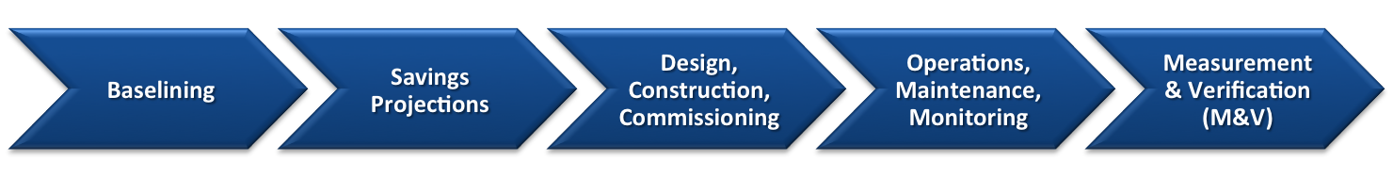
The Investor Ready Energy Efficiency (IREE) certification of the Investor Confidence Project (ICP) Europe fosters transparent, consistent and trustworthy projects by standardising project development, the application of existing standards and best practices, and an independent verification during project development and operations. This allows for investment decisions with higher confidence in the technical fundamentals and the planned energy savings as well as lower transaction costs.
Fig. 1: Five phases of best practice project development according to ICP Protocols

The ICP Protocols at the centre of ICP were developed in a participatory approach together with technical experts and other stakeholders. These Protocols define a best practice process that is based on existing standards and consists of five phases: The development of the energy baseline, the calculation of expected energy savings as well as three implementation phases, including measurement and verification. This covers all aspects of energy efficiency project development and documentation in a structured and consistent way.
While a project is certified before its implementation, IREE guarantees that energy consumption is optimised after implementation and that energy savings are measured and verified according to the IPMVP standard. Usually, a project is certified at the end of the project development phase to give the project owner or investor/CFO more confidence for their investment decision.

Results
The IREE certification was previously successfully implemented in the buildings sector across Europe, with implementation in industry currently underway. The first industrial projects are developed and certified in the food processing and printing sectors in Austria and show that the project owners benefit from more robust baseline and savings calculations, an additional layer of quality assurance and a stronger focus on proper project implementation.
In particular, ICP reduces risks and transaction costs of a technical due diligence, makes projects comparable and lays a foundation for successful project implementation. The integrated monitoring and verification of energy savings increases the reliability of projected energy savings. ICP has also developed a network of qualified project developers and quality assurance assessors, a global Investor Network of energy efficiency investors and a European ally network with 200+ stakeholders.
In short, ICP Europe has used an open, participatory process to develop a market-oriented framework for developing and certifying energy efficiency projects which has the potential to transform the market for energy efficiency investments. Thereby, ICP wants to close the gap between energy efficiency projects and investors and provides new market opportunities for project developers and other energy efficiency professionals.
For more information on ICP visit http://europe.eeperformance.org.

Hietzinger Hauptstrasse 28, 1130 Vienna, Austria, +43 664 8118002, andreas.lindinger@denkstatt.at, www.denkstatt.eu

